## Sitecore Hackathon 2018

# Team Information

Team Name: **Shooting Stars**

Team Members: Pasan Samarakoon, Chaturanga Ranatunga

# Module Information

Category : Sitecore JavaScript Service

Name : JSS Twitter Component

Purpose : Show tweets in time line base on twitter setting

Description :

JSS Twitter Component connects to provided Twitter account and displays tweets from that account

As a widget in the Sitecore website.

This module is JSS react application that will allow Sitecore editors to add JSS Twitters component into a page and configure twitter account and its size settings in Sitecore.

External Modules: https://www.npmjs.com/package/react-twitter-widgets

# Screenshots:

Data Source Item

Sitecore Editors can set “screenName” field and “username” field as needed. JSS Twitter component will fetch Twitters from the Twitter account specified in the “username” field and display it as a widget on the Sitecore website.

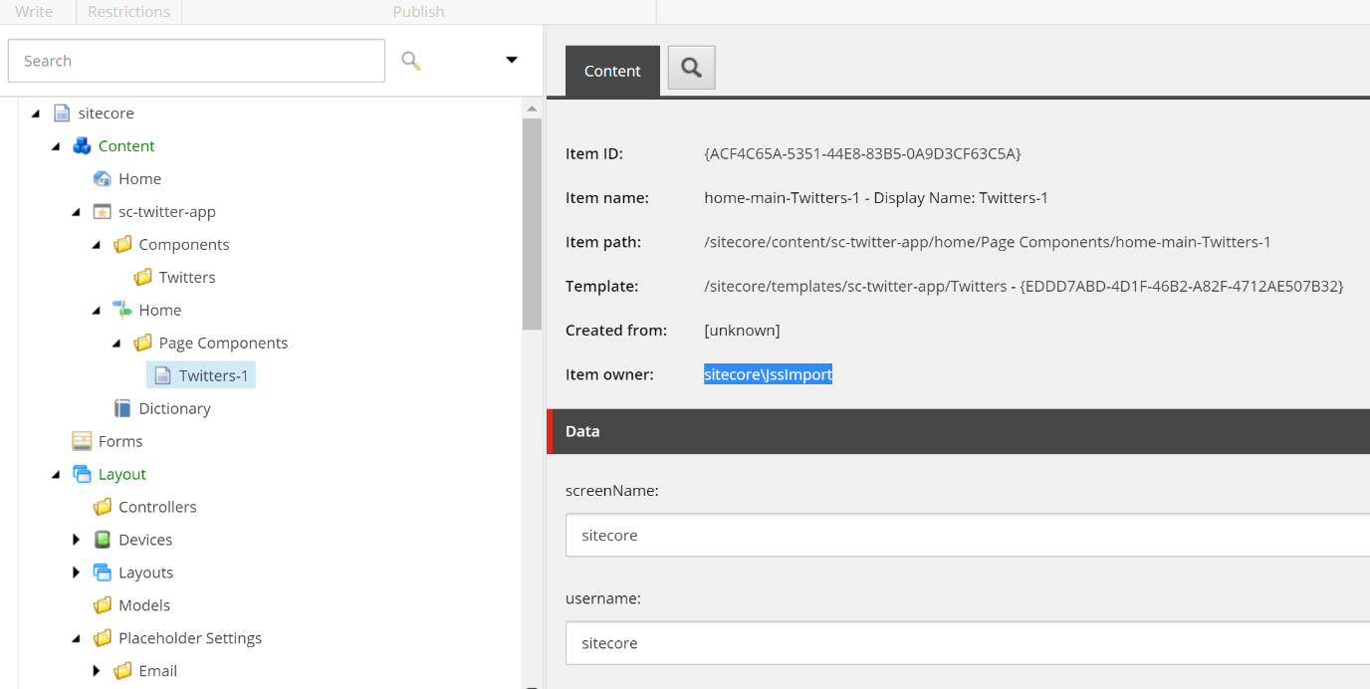

JSS Twitter Widget Component on Front-End Website

This component shows tweets from @Sitecore account on the webpage



JSS Twitter Component Rendering Parameters

User will be able to configure size of the widget using Rendering Parameters settings on the component

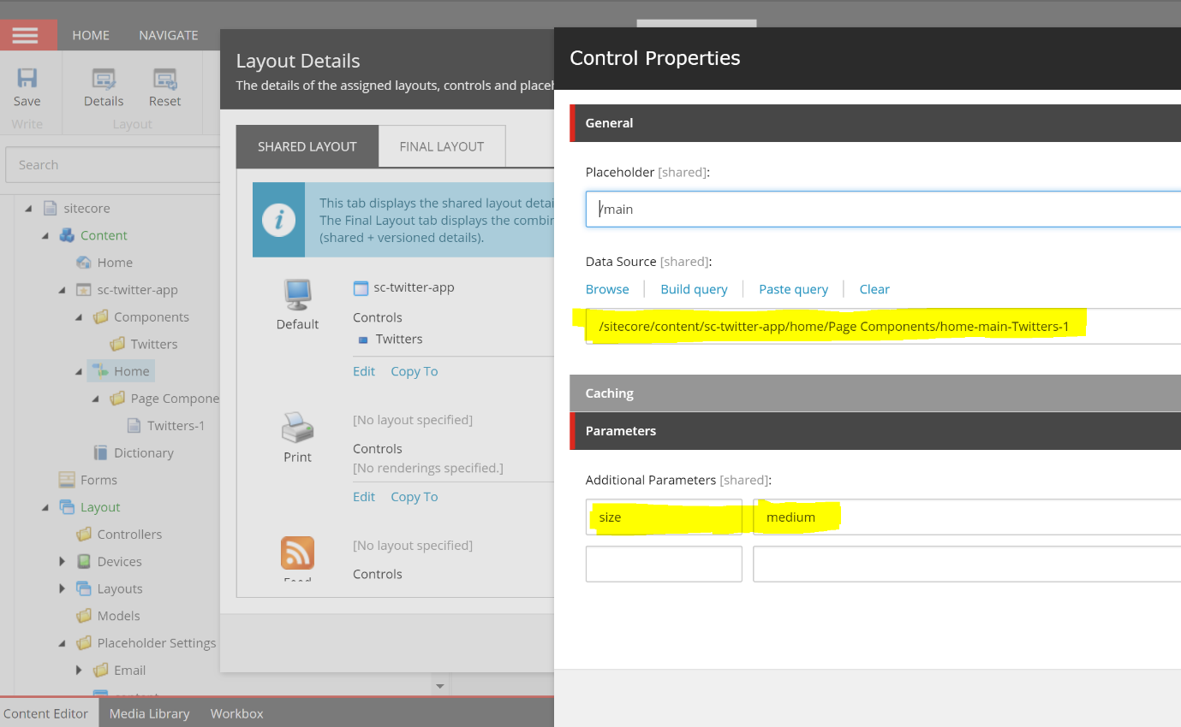

Twitter component related placeholder settings and renderings Items

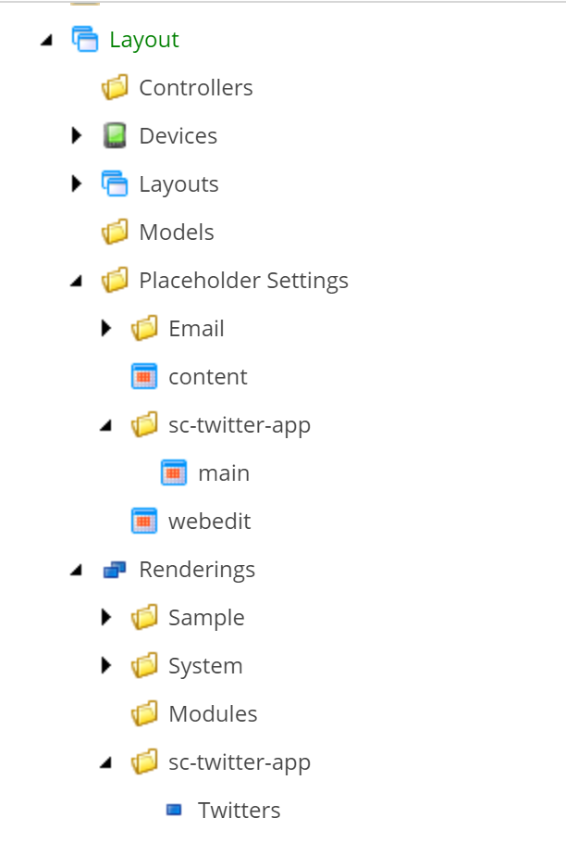

Twitter component related content items

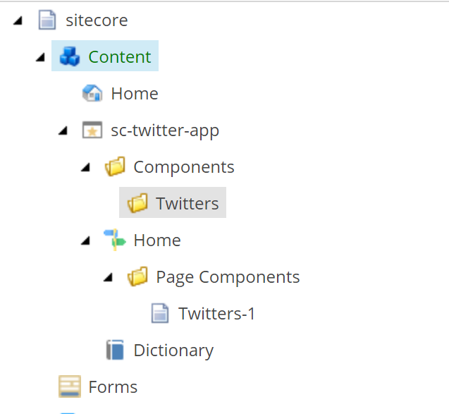

Twitter component related templates

